ELEMENTS OF MECHANICAL ENGINEERING [ME13 / 23]

Steam boilers:

Definition of boilers:

- Boiler is defined as a closed metallic vessel in which the water is heated beyond the boiling state by the application of heat liberated by the combustion of fuels to convert it into steam.

Function of a boiler:

- The function of the boiler is to supply the steam at the required constant pressure with its quality either dry or as nearly as dry, or superheated. The steam can be supplied from the boiler at a constant pressure by maintaining the steam generation rate and the steam flow rate.

CLASSIFICATION OF BOILERS:

According to the circulation of water and hot gases:-

- Fire Tube boilers:-In fire tube boilers the hot flue gases produced by the combustion of fuel passes through the tubes which are surrounded by water.

Eg: - Cornish boilers, locomotive boilers, marine boilers and Lancashire boiler.

- Water Tube boilers: - In water tube boilers water circulated inside the tubes, while the hot gases produced by the combustion of fuels pass around the tubes.
Eg: - Babcock and Wilcox boiler, Stirling boilers…etc.
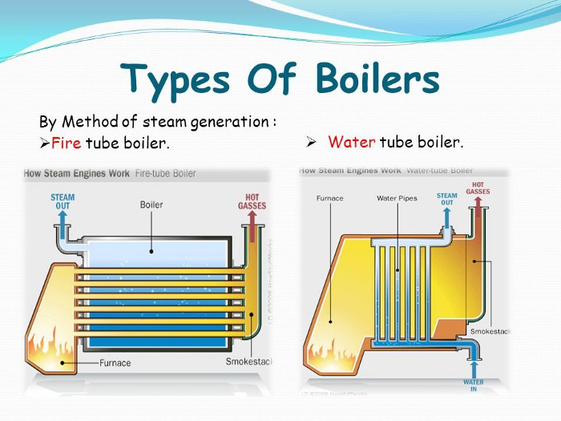

According to the location of furnace.

a) Internally fired boilers: - If the furnace is situated inside the boiler shell, the boiler is called internally fired boilers. Most of the fire tube boilers are internally fired.
b) Externally fired boilers:-If the furnace is situated outside the boiler shell, the boiler is called externally fired boilers. Water tube boilers are always externally fired.

According to the circulation of water.

- Natural circulation: - In these boilers, water is circulated by natural convection currents that are set up due to the temperature difference.
- Forced circulation: - water is circulated with the help of pump driven by a motor. Forced circulation is used only in high pressure and high capacity boilers like Lamont boilers and Benson boilers, etc...

According to the axis of the shell.

- Vertical boilers: - axis of the boilers shell is vertical. Ex:-Cochran boilers.
- Horizontal boilers:-axis of the boilers shell is horizontal. Ex:-Babcock &Wilcox boilers, Lancashire boilers.

According to their uses.
- Stationary boilers
- Locomotive (Mobile) boilers
- Marine boilers, etc…..

Bobcock and Wilcox boiler (Water tube Boiler)
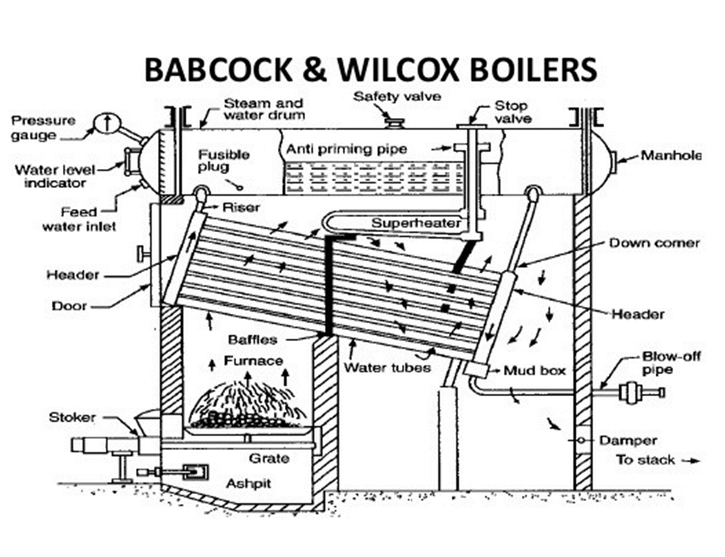

Construction:
It is a horizontal, externally fired, natural circulation, water tube boiler. It consists of mainly four parts: (a) Steam and water drum – It is filled with three-fourths water. It stores the feed water and steam. (b) Water tubes – number of water tubes are connected through downtake header and uptake header in which water circulates as shown in fig. (c) Baffle plates- it is placed across the water tubes .it deflect the hot gases coming out from the furnace to allow the hot gas pass around water tubes. (d) Internal furnace– it burns the coal to produce hot flue gases. (e) Super heater – it is set of U-tubes just below the boiler drum, it converts the steam into superheated steam.
Working: - Water is introduced into the boiler drum through the feed valve. Water descends into the down take headers, into the water tubes and then into the uptake headers. The hot flue gases from the furnace pass over the water tubes. The path of the hot gases is guided by the baffle plates as shown in the fig., and passes out to the chimney. As the hot gases pass over the water tubes, the water gets converted into steam. This steam due to low density rises up the tube through the uptake headers and reach the top of boiler drum. This sets up a natural circulation of water. The steam collected in the boiler is wet. This is made to pass through the super heater U-tubes just below the boiler drum. The hot gases on their way out pass over these tubes hence converting the steam into superheated steam. The superheated steam in then passed out to the turbine through the steam stop valve. For safety the boiler consists of safety valve, steam stop valve, blow-off pipe, and pressure gauge, etc.

Lancashire boiler:
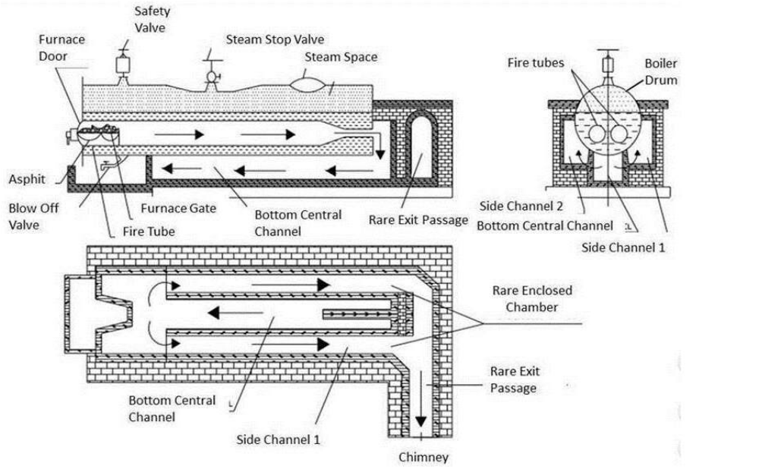

Construction & Working:

It is a horizontal, internally fired, natural circulation, fire tube boiler.

• This boiler consists of a large horizontal cylindrical shell placed on the brick wall.

Two large flue tubes are placed inside the shell, which carry the hot flue gases.

- The boiler shell is filled with water to three-fourths of its volume and the remaining space is the steam space.

- Hot flue gases from the combustion are made to pass through the flue tubes.

- In the first run it passes from the front end to the rear end of the boiler.

- At the rear end they are made to pass to the bottom central channel.

- In the bottom central channel the hot gases travel from rear end to the front end of the

boiler. This is the second run.

- At the front end the hot gases enter into side channels 1 and 2 and travel to the rear end of the boiler. This is the third run.

- At the rear end hot gases coming out of channels 1 and 2 are made to exit to the

chimney through the rear exit passage.

- During the first, second and third pass the heat transfer takes place between hot flue gases and the water in the shell, converting water into steam.

- The steam gets accumulated in the steam space at the top.

- Super heater (set of U-tubes) is placed at the rear end of the shell.

- For safety the boiler consists of safety valve, steam stop valve, blow-off valve, pressure gauge, etc.

BOILER MOUNTINGS AND ACCESSORIES:

MOUNTINGS:

- Water level indicator: It indicates the level of water in the boiler drum.

- Pressure gauge: Indicates the pressure of the steam in the boiler.

- Safety Valves: When the pressure inside the boiler drum exceeds the desired level, the safety valves blows off the excess steam from the boiler.

- Steam stop valve: It regulates the flow of steam from the boiler.

- Feed check valve: It checks the level of water in the boiler drum.

- Blow off valve: Its function is to remove periodically the sediments and impurities collected at the bottom of the boiler.

7) Fusible plug: It is a device used to extinguish the fire in the furnace.

ACCESSORIES:

- Economizer: The function of an economizer is to heat the feed water, before being supplied to the boiler, using the products of combustion (flue gas) discharged from the boiler.

2. Air preheater: The function of an air preheater is to preheat the air being supplied to the furnace for combustion.

- A super heater: is a device used to convert saturated steam or wet steam into dry steam.

- Feed pump: pumps the water into the boiler at high pressure.

- Steam separator: it is used to separate the water particles is present in the steam before enters the turbine or engines.

- Steam trap: it is used to drain off the condensed water accumulated in the steam pipes and steam separator without allowing the escape of high pressure steam from it.

Difference/comparison between Lancashire boiler (Fire tube Boiler) and Babcock and Wilcox
Boiler (Water tube Boiler)

